5.64: a)
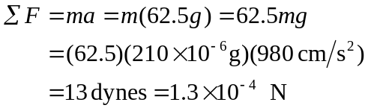
This force is 62.5 times the flea’s weight.
b)
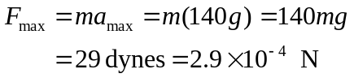
Occurs at approximately 1.2 ms.
c) 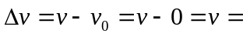 area under a-t graph. Approximate area as shown:
